NAME: K Yamini
REG NO: 192572181

Write a Prolog Program for fruit and its color using Back Tracking.
Aim:
To implement a Prolog program to find the color of different fruits using facts and Prolog backtracking.
Algorithm:
- Start the program.
- Define facts containing fruits and their colors.
- Create a predicate fruit_color(Fruit, Color).
- Store different fruit-color combinations.
- Give a query with a fruit name.
- Prolog searches for a matching fact.
- If multiple answers are available, Prolog uses backtracking to find the next answer.
- Display the fruit and its color.
- Stop the program.
Prolog program:
% EXPERIMENT 26
% Fruit and Color using Backtracking

% Fruit-color facts
fruit_color(apple, red).
fruit_color(apple, green).
fruit_color(banana, yellow).
fruit_color(orange, orange).
fruit_color(grapes, green).
fruit_color(grapes, purple).
fruit_color(mango, yellow).
fruit_color(watermelon, green).

% Display fruit and color
show_color(Fruit) :-
fruit_color(Fruit, Color),
write('Fruit: '),
write(Fruit),
write(' Color: '),
write(Color),
nl.
Input:
?- show_color(apple).

Output :
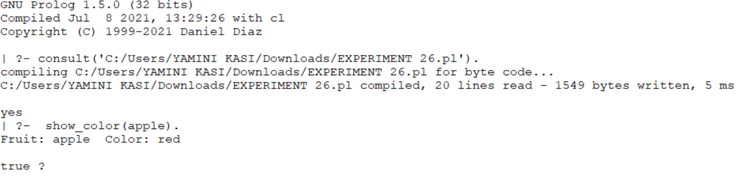
Result:
Thus, the Prolog program for finding fruit and its color using backtracking was successfully implemented and executed.

